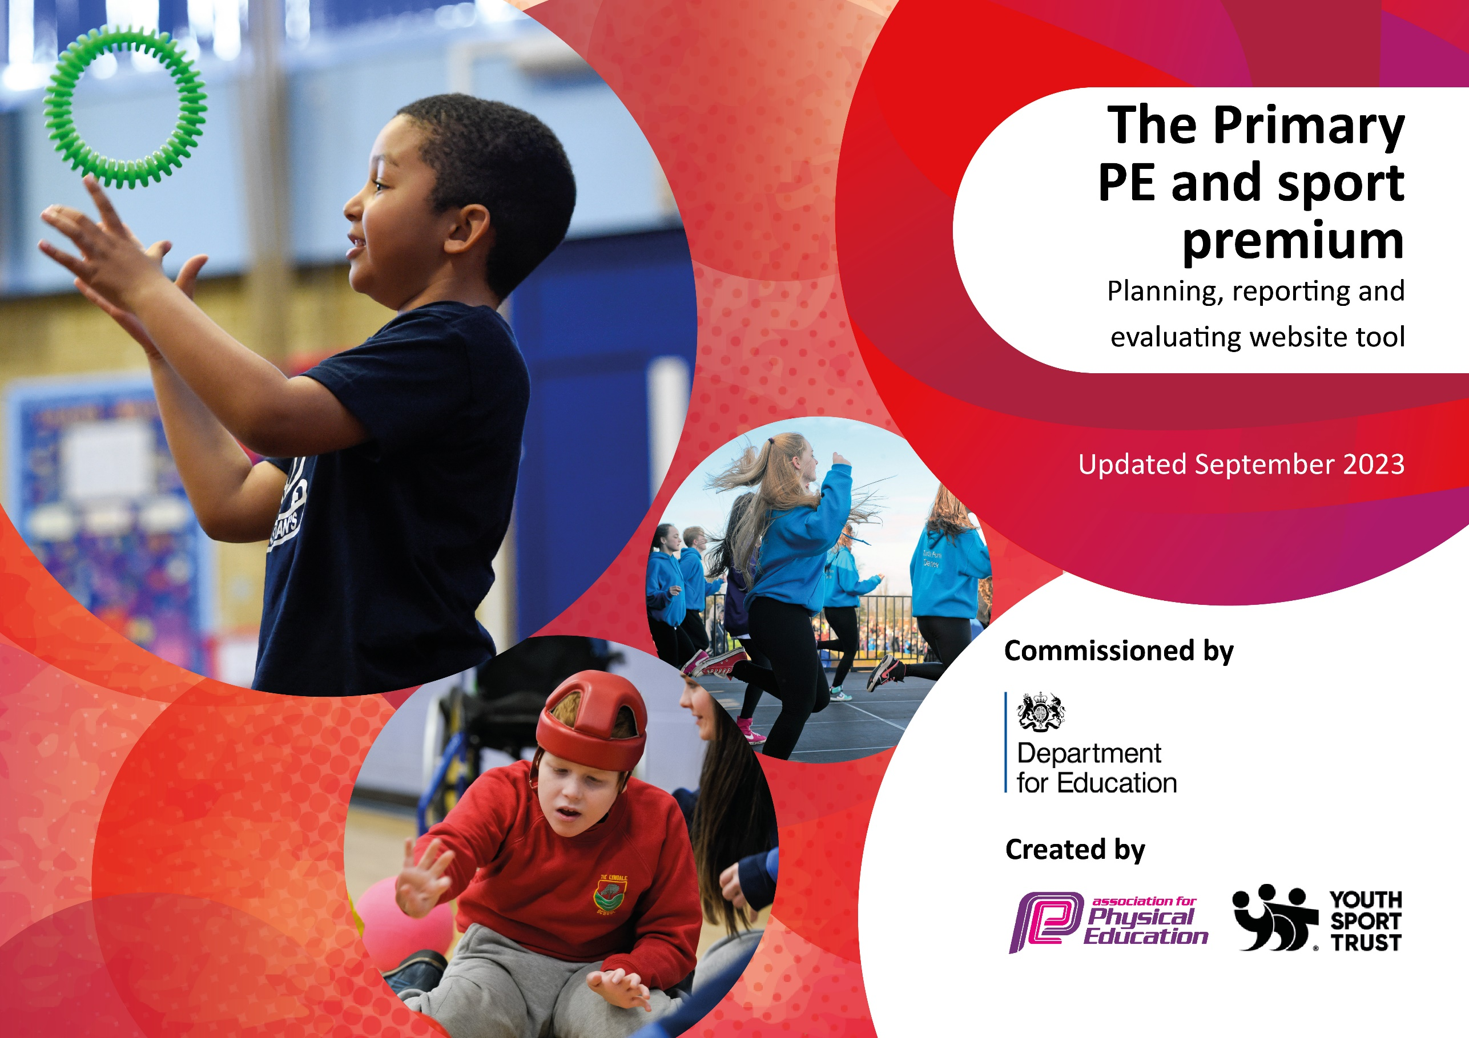

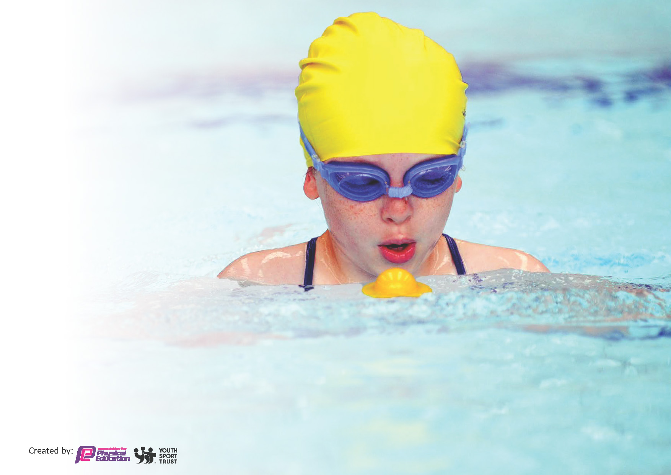
This template can be used for multiple purposes:
by:
- It enables schools to effectively plan their use of the Primary PE and sport premium
- It helps schools to meet the requirements (as set out in guidance) to publish information on their Primary PE and sport premium
- It will be an effective document to support Ofsted inspections enabling schools to evidence progress in Physical Education (PE) and evidence swimming attainment, which forms part of the PE National Curriculum. We would recommend schools consider
the Intent, Implementation and Impact of any spend, as examined within the Education Inspection Framework.

It is important that your grant is used effectively and based on school need.

Schools must use the funding to make additional and sustainable
improvements to the quality of the PE, School Sport and Physical Activity (PESSPA)
they offer. This means that you should use the Primary PE and sport premium to:

- Build capacity and capability within the school to ensure that improvements made now will benefit pupils joining the school in future years
- Develop or add to the PESSPA activities that your school already offers.

The Primary PE and sport premium should not be used to fund capital spend projects; the school’s core budget should fund these. Further detail on capital expenditure can be found in the updated Primary PE and sport premium guidance.

The Primary PE and sport premium guidance, outlines 5 key priorities that funding should be used towards. It is not

necessary that spending has to meet all the key priorities, you should select the priorities that you aim to use any funding towards.

Although completing this template is not a requirement for schools, schools are required to publish details of how they spend this funding. Schools must also outline what the impact this funding has had on pupils’ PE and sport participation and attainment and how any spending will be sustainable in the future. All funding must be spent by 31st July 2024.

The Department for Education has worked closely with the Association for Physical Education (afPE) and the Youth Sport Trust (YST) to develop this template and encourages schools to use it. This template is an effective way of meeting the reporting requirements of the Primary PE and sport premium.
Review of last year’s spend and key achievements (2022/2023)

We recommend you start by reflecting on the impact of current provision and reviewing your previous spend.

Activity/Action | Impact | Comments
Ensuring that each class has two hours of specialist PE provision in curriculum time.  Providing opportunities for active and engaging playtimes  Providing after school clubs in a wide range of sports  Offering opportunities to represent the school in competitions for all  Wide range of sports coaches in offering a variety | Active/Engaged children across lessons and playtimes have shown an increase in engagement in lessons and active playtime  Competition has become key in school and raised the profile of PE and Sport  Coaching opportunities in Hockey/Cricket/Dance and Baseball have seen children join clubs outside of school to continue sport | PE coach has left summer 2022/3  Was a big overhaul to change culture in the school and offer extra provision  TOA provided a good link as did chance 2 shine and OHC
Highlight the links between PE and SS and mental and physical health and well being.  Use it as a driver to get children in to school to help whole school improvement in attendance. | Workshops were delivered and links made with the science curriculum, children showed an understanding of the links in trust wide survey | School needs to build on this to embed
Provide teachers with a wide range of high quality sports coaches to learn from across different sports.  Offer CPD opportunities for all staff in PE.  To offer children to opportunities to experience a wide range of sports throughout the year to find one they love | Coaches in Hockey and cricket have helped upskill teachers in unfamiliar areas | Turnover of staff at the end of the year made this a recurring need
Ensure that every child has the opportunity to compete and those who are G&T can push themselves at a regional level. | Children have represented the school locally and at high level competition, with footballers reaching regional finals | Use this success to build the culture.

Key priorities and Planning
This planning template will allow schools to accurately plan their spending.

Action – what are you planning to do | Who does this action impact? | Key indicator to meet | Impacts and how sustainability will be achieved? | Cost linked to the action
Hire a variety of coaches and build community links to ensure a wider range of sports are offered and children have wider opportunities.  Continue to improve playground area and opportunities for active play at breaktimes. | This will impact children and staff through creating a variety of engagement opportunities in and out of lessons and offer a wide range of opportunities.  Travel to events will be included. | Key indicator 2 -The engagement of all pupils in regular physical activity – the Chief Medical Officer guidelines recommend that all children and young people aged 5 to 18 engage in at least 60 minutes of physical activity per day, of which 30 minutes should be in school.  Key indicator 4: Broader experience of a range of sports and activities offered to all pupils. | Children will be active and engaged, the equipment should allow for more than one year.  Pupil voice should show engagement in new sports and children should hopefully link to local pathways. | £14,000  Sports Coaches  Cost of equipment  £4,500

Build knowledge of staff in a variety of sports to create high skilled staff in our workplace  Ensure opportunities for competition for all and extension for Gifted and Talented children | Staff whose knowledge will increase  Children who will benefit from this in lessons  Children who have opportunities  School Community through shift in culture of success | Key Indicator 1: Increased confidence, knowledge, and skills of all staff in teaching PE and sport.  Key indicator 5: Increased participation in competitive sport. | Primary teachers more confident to deliver effective PE supporting pupils to undertake extra activities inside and outside of school,  Children to have represented the school in multiple sports  Children to have opportunities to compete within our Sports Partnership and beyond | £3000  £2000 – equipment, transport, staffing

Key achievements 2023-2024
This template will be completed at the end of the academic year and will showcase the key achievements schools have made with their Primary PE and sport premium spending.

Activity/Action | Impact | Comments
Hire a variety of coaches and build community links to ensure a wider range of sports are offered and children have wider opportunities. | All children have 2 hours of PE. Every child had an opportunity to swim in school this year.  Dance teacher has been a very important addition as identified as target area | Swimming pool on site, which was funded separately helped ensure this was built in even further  Oxford HC and Chance to Shine as well as links with Headington, Radley and TOA who offered Baseball were key this year.
Continue to improve playground area and opportunities for active play at breaktimes. | Children more engaged, specific sports area has helped children here | ‘Football area’ a success but dire need for climbing frame
Build knowledge of staff in a variety of sports to create high skilled staff in our workplace | CPD taken place in a variety of sports which will be carried forward this year | Baseball was a real success and has upskilled a key staff member
Ensure opportunities for competition for all and extension for Gifted and Talented children | Children have all experienced sport outside of school  G&T children have had successes at regional level which has been celebrated and helped to build the sporting culture at the school | Huge success – the parent feedback is about how much the school has changed here.  City level champions across multiple sport  3rd Place in Oxfordshire Hockey  2nd Place Athletics  1st Place Football (Reached National Finals)

Swimming Data
Meeting National Curriculum requirements for swimming and water safety.
Priority should always be given to ensuring that pupils can perform safe self-rescue even if they do not fully meet the first two requirements of the National Curriculum programme of study

Question | Stats: | Further context  Relative to local challenges
What percentage of your current Year 6 cohort can swim competently, confidently and proficiently over a distance of at least 25 metres? | 87.5% | Use this text box to give further context behind the percentage.  e.g., 30% - we are struggling to get pool space due to our local pool closing so we have had to use a much smaller local school pool. We have had to limit the number of pupils attending swimming lessons during one term which means some pupils have attended fewer swimming lessons than others.
What percentage of your current Year 6 cohort can use a range of strokes effectively [for example, front crawl, backstroke, and breaststroke]? | 75% | Use this text box to give further context behind the percentage.  e.g., Even though your pupils may swim in another year please report on their attainment on leaving primary school at the end of the summer term 2024

What percentage of your current Year 6 cohort are able to perform safe self-rescue in different water-based situations? | 25% | Use this text box to give further context behind the percentage.
If your schools swimming data is below national expectation, you can choose to use the Primary PE and sport premium to provide additional top-up sessions for those pupils that did not meet National Curriculum  requirements after the completion of core lessons. Have you done this? | Yes/No | No – we did however have a pool on site which was funded by Sport England.
Have you provided CPD to improve the knowledge and confidence of staff to be able to teach swimming and water safety? | Yes/No | No.

Signed off by:

Head Teacher: | Paul Higgins
Subject Leader or the individual responsible for the Primary PE and sport premium: | Paul Higgins
Governor: | Ian Courtney – Chair
Date: | 31.7.24

